https://global.com/ie/legal/
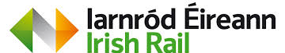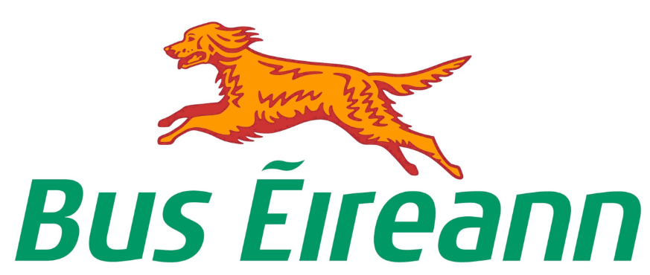
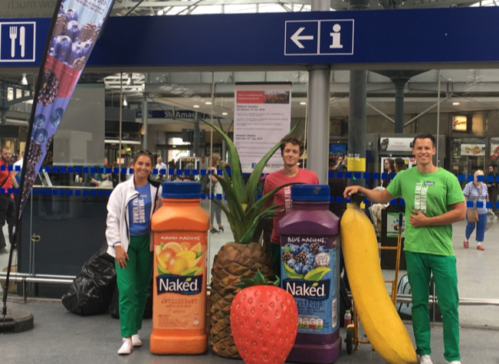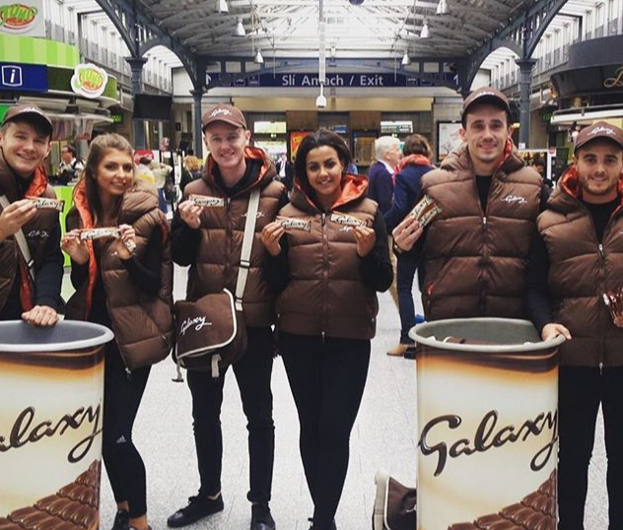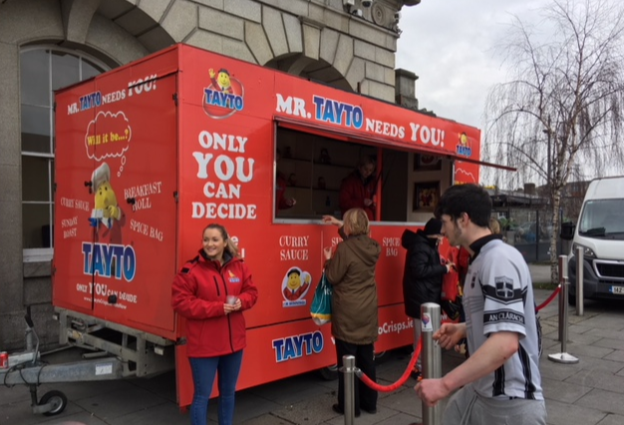
Company Name
Account Exec
Job Title
Address

Tel / Mobile

E Mail Address

EVENT DETAILS
Event Brand and Title

STAFFING DETAILS
Event Supervisor | Contact Number
Station Safety Briefing Required* Y/N:
*advance requirement for all new bookings per station, or to be renewed once a year
Total number of staff in attendance: include Brand Ambassadors, supervisor, plus any drivers, film crew, entertainment or other staff

EVENT LOCATIONS:
Please note: on external event days, local rail or bus stations may not be available due to Iarnród Éireann / Bus Eireann / Gardaí / local authority traffic management restrictions. On those days, brand to hand events are on request only.
Station Name
Event Date
Event Start Time
Event Finish
Event Set Up Time
Event Dismantling Time
Name of External Event Tie In

EVENT ACTIVITY
Please provide a description of the activity to be undertaken
Please indicate if event is to be positioned at multiple locations within the station (internal or external, on board)

Provide full event footprint / dimensions (m), plus description / dimensions of all equipment or props to be used on site
How is equipment being brought in and assembled, what equipment to be used
Supply images or mock-ups where available

Please provide details of positioning of equipment within set up area i.e., banners, flags, tables, stands, bins
Supply images or mock-ups where available

Is a power source required; if so, for what use: | Voltage Required | Will the event require a generator, how will it be earthed, positioned

Please provide a description of all staff uniforms and personal data collection devices being used (i.e. electronic, paper etc)

Are samples being distributed: |  | Number of samples to be distributed at each location:

Please provide details of samples: Type, size, weight, hot, cold, wet, dry etc
For hot samples, how are they distributed: i.e. container material and dimensions
Will there be a litter / wet spill removal plan in place, please describe:
*** ALL LITTER GENERATED AT EVENTS MUST BE REMOVED BY EVENT STAFF BEFORE LEAVING STATION ***

Will event be filmed /recorded? If so, describe how. Please confirm that release forms will be provided and supply us with an advance copy of form to be used
Do you want us to take part in your Social Media activity? i.e. retweet posts. If so, confirm handles or #hastags
Any other information of relevance

PLEASE NOTE:
- We require notice of bookings at least 5 working days ahead of/before preferred activation date.
- Leafleting is not permitted
- Set up / dismantling times that run longer than 30 minutes either side of an event will be counted as part of the total event time.
- Each promotion is priced according to its own merit. Rates quoted are based on standard activations delivering reach within the station local area only.
- Events that are being filmed and / or recorded for broadcasting and publishing online and on other traditional media formats will be priced accordingly.
- A cover note, or cert of Public Liability and Employer’s Liability Insurance, and where applicable Products Liability Insurance, must be provided to Global Media and Entertainment (Ireland) Ltd. prior to any sampling event taking place.
- A Method Statement (event permit) will be issued once the event activity has been approved by CIÉ. Any deviations, no matter how minor, from the described event activity as outlined in this permit request form or detailed in the Method Statement will not be permitted on the day and may result in the sampling permit being withdrawn without further notice. Therefore, any and all, revisions to event activity must be communicated to the Global team, as they must be noted in the permit ahead of event activity commencing.

- The final rate for a sampling event will be based on all aspects of the specific event as outlined in this document. However, any subsequent changes to the event execution may result in a revision to the event rate.
- Sales Terms and Conditions are available at: https://global.com/ie/legal/

